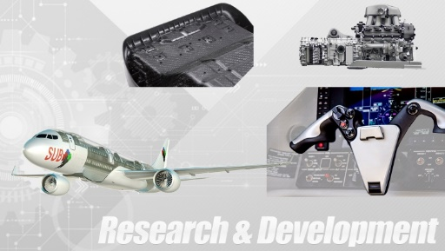
Which materials are used for effective sterilization?
With the presence of increasingly aggressive viruses, the need to find easily sterilizable materials has become really important ...

Metals such as silver are known for their oligodynamic effect that neutralizes bacteria. However, their densities, shapes and prices do not always make them competitive with some thermoplastics.
- High temperature sterilization:
The classic sterilization is known as "autoclave" sterilization. It is the oldest technology but also the most used in hospitals to sterilize multi-purpose components. In fact the components are placed in a pressure vessel in which they are brought to high temperatures (>120°C) in the presence of steam. If the components need to be sterilized many times, it is therefore advisable to choose the most suitable thermoplastic. The material must be able to be sterilised many times without losing its physical and mechanical properties.
For this, two factors must be taken into account:
- The heat resistance of the component.
- The moisture resistance of the component.
Indeed, the chosen thermoplastic must have, first of all, a deflection temperature under load equivalent to or higher than the temperature used for sterilization. Otherwise, the polymer will be deformed and therefore degraded from the first sterilizations.
In addition, the polymer used must be relatively resistant to hydrolysis. In fact, some thermoplastics, such as polyamides or polycarbonates, have a low hydrolytic stability which makes their use irrelevant in this type of case. The reaction that applies here can be seen in the following diagram :

+ H₂O
H
HO
T° > 60°C

Figure 1 : Influence of water on Polycarbonate (Hydrolysis)

These considerations obviously do not apply to dry sterilization. However, as the temperatures used will be higher, the deflection temperatures under load will be even more important to know.
The following table shows the example of some polymers related to their deflection temperature under load, their hydrolytic stability and therefore their resistance to autoclaving:
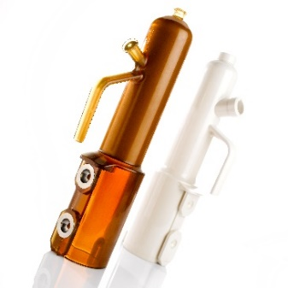
Table 1: Sterilization capabilities for different polymers
Polymer | Heat deflection temperature (°C) | Hydrolytique stability | Autoclaving capability at 121°C
Polycarbonates | 170 - 220 | Poor | Poor
HDPE/LDPE | 60 - 120 | Good | Poor
PTFE | 75–130 | Good | Fair
PEI | 200-210 | Good | Fair
PEEK | 160 | Good | Good
Polysulfones | 170 - 215 | Good | Very Good

In conclusion, the vast majority of polymers can be sterilized up to 5 times. From 100 sterilizations onwards, polymers such as PEEK, PEI, liquid crystal polymers and polysulfones will be recommended. After 1000 sterilizations, polyphenylsulfone polymers (PPSU) are preferred as they have the ability to withstand this type of sterilization very well.
Figure 2 : Medical filling pumps based on PSU and ceramic overmouldings
- Other sterilizations:
Other sterilizations are also used industrially. This is the case of ethylene oxide (EtO) sterilization, which is interesting because it does not use steam but requires flammable and toxic processes. Ultraviolet or gamma radiation such as electron beams or plasma are also commonly used to sterilize medical devices.
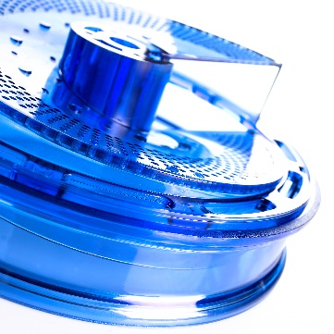
All these sterilizations have their own specificities and constraints and are not suitable for all types of materials. Feronyl, benefiting from a significant experience in the injection of polymer components for medical applications, is thus able to help you to choose the most suitable material. The different constraints will be taken into account and we will be able to make coherent and efficient proposals.
In addition, for very specific applications, our various material suppliers could guide us in the choice of the most suitable thermoplastic. Over the years, we have developed strong partnerships with these groups and we know where to turn according to the type of project.
Figure 3 : Pharmaceutical components based on PC made by Feronyl
For more details, please contact our experts:
Arthur Ollivier  Technical Sales Engineer  Materials chemistry – Engineering degree  Phone: +32 478 78 08 37  Mail: ollivier.a@feronyl.com | Feronyl  Boulevard Industriel, 101  7700 – Mouscron [Belgium]  Phone: +32 56 85 75 30  Mail: feronyl@feronyl.com
Established in Mouscron (Belgium) since 1950, Feronyl is one of the SUB-ALLIANCE E.I.G. companies.
SUB-ALLIANCE is specialized in manufacturing of advanced mechanical systems, mainly composed of polymers, composites, metals and transmissions. The four business units can provide stand-alone manufacturing capabilities or join forces on common Research & Development projects.
The four business units are Feronyl, Dedecker Precision Mechanics DPM, Tecnolon Works and Grimonprez Transmissions Gears.

